Alexandria Marbury
Professor Penmatsa
Software Development Lifecycle
February 27, 2022
ChadaTech Retrospective
The ChadaTech project offered a valuable opportunity to apply Scrum Agile principles in a collaborative, real-world context. The separation of roles, such as product owner, scrum master, developer, and tester, helped to divide responsibilities effectively and focus on individual progress. The Scrum Master maintained workflow efficiency, coordinated meetings, verified project compliance with requirements, and ensured alignment with Agile values. The Product Owner clarified the client’s needs in the design and prioritized features to deliver maximum value to the customer. As a Tester, it was my job to ensure the user story met client expectations and passed functional requirements such as verifying the webpage layout displayed the top five destinations and allowed users to scroll properly. The Developer created the design, implementing features, and regularly report progress throughout the project.
During the project, collaborations and communication proved to be essential. The Product Owner analyzed client interviews to extract system requirements, while I refined those requirements into testable conditions. For instance, when layout specifications were unclear, I reached out for clarification using structured communication as shown in my email to the Product Owner later in the lifecycle review. These interactions reinforced the importance of transparency within Agile teams. As changes occurred mid-project, our team effectively reprioritized the product backlog and redefined user stories to maintain progress without compromising quality.
One key lesson I learned throughout the process was that Agile projects succeed through flexibility and collaboration. At times, balancing test case documentation with ongoing feature development was challenging, but daily stand-up meetings kept everyone aligned. By adjusting priorities collaboratively, we reduced rework and ensured that both development and testing aligned with the evolving client vision. The Agile approach allowed us to adapt quickly compared to traditional Waterfall methods, which would have delayed delivery after requirement changes.
When communicating with the team, it is mandatory that each member provides clear, detailed descriptions of what clarifications are needed and why. For instance, as a tester, I requested more information about how long descriptions should be and how the choice setups should be arranged for users to select their preferences for their profiles. Here is an example of how I would go about communicating with the product owner.
To: Product Owner
Subject: Request for Clarifications on User Stories
Dear Product Owner,
After reviewing the current set of user stories, I would like to request clarification on several key elements to ensure that the development and testing processes align with the client’s expectations. Having this information will help the team maintain consistency in design, improve user experience, and avoid unnecessary rework during later stages of implementation. Specifically, I would like to confirm the content structure, layout preferences, and functionality options related to the user interface and user settings.
Outlined below is a summary of the areas where further guidance would be helpful:
User Story One
- Desired length and level of detail for user descriptions
- Preferred layout format (slideshow vs. vertical list)
- Color scheme or design theme that aligns with the client’s branding
User Story Two
• List of available user choices (vacation type options)
- Additional configuration options permitted in the settings menu
- Whether each choice should include a brief explanatory description for clarity
User Story Three
- Whether promotional deals should be visually emphasized (bolded text or highlighted)
- Preferred layout and format for the deals page to ensure clarity and visual appeal
Providing clarification on these points will enable the development and testing teams to create a product that meets both user needs and client specifications while maintaining design coherence. Please let me know if we can schedule a short meeting or receive written guidance to address these matters.
Thank you for your time and assistance.
Kindest regards,
Alexandria Marbury

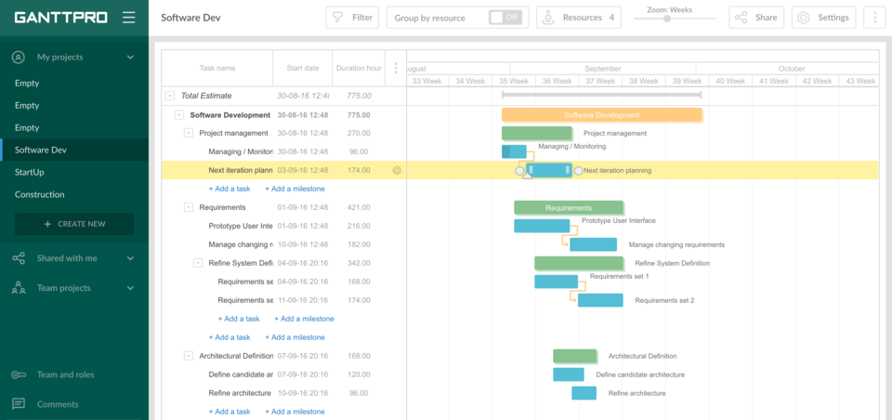
These bullet points help create a clear structure for communication and ensure that no key clarifications are overlooked. I also enhanced this artifact by adding a visual Gantt chart that tracked task completion by role and sprint. This improvement made it easier for the team to align development and testing milestones with sprint goals, ensuring transparency across the workflow.
Figure 1 Example of a Gantt chart generated using GanttPRO software, showing project task scheduling and progress tracking.

The Scrum-agile approach is ideal for this project because it supported flexibility as the client requirements evolved. Compared to the waterfall method, Agile allowed the team to integrate new features without restarting development. This experience conveyed the importance of communication and adaptability. Moving forward, I plan to apply these same practices in professional Agile environments by implementing test-driven development and continuous feedback loops to improve software quality and collaboration across teams.

Reference
GanttPRO. (2022). GanttPRO Gantt Chart Software [Image]. Wikimedia Commons. https://commons.wikimedia.org/wiki/File:GanttPRO_Gantt_Chart_Software.png

